MEDIATOR’S INFORMATION

LE HONG HANH
 | Chief Director, Law & Development journal  Director of Institute of ASEAN Law and Economics |  | 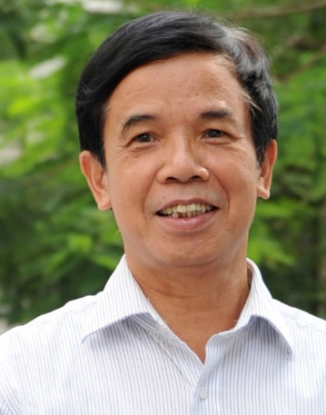
 | 3th floor, Star Tower, Duong Dinh Nghe st., Yen Hoa ward, Cau Giay dis., Hanoi
 | lhhanh@fpt.vn
 | Fluent in English, Russia, and good in French
Training
1976 |  | LL.B., with major of International Law  Moscow State Institute of International Relations (Russia)
1995 |  | LL.M., with major of International Trade Law
1986 |  | LL.D., with major of Civil – Economic Law
Career
9/1976 |  | Worked in the Government Law Committee (currently the Ministry of Justice)
11/1977 |  | Lecturer at Vietnam Law College to teach economic law, the Director of Department of Economic law of the College
From 1979 |  | Vice-Dean and then Dean of the Faculty of Economic Law of Vietnam Law College
1983 |  | Was sent to Soviet Union to complete the LL.D. degree at Moscow State University
8/1986 |  | Dean of the Faculty of Economic Law of Vietnam Law College
11/1987 |  | Vice-Rector of Hanoi Law University
1993 |  | Was sent to Harvard University as a visiting scholar under Fullbright program then completed the LL.M. program at Havard Law School.
1995 – 2006 |  | Vice-Rector of Hanoi Law University
1996 |  | Was acknowledged as Teacher of Merit and granted the title of “Associate Professor”.
1993 – current |  | Arbitrator of the Vietnam International Arbitration Centre
 |  | Standing member of the Central Committee of Vietnam Lawyers Association, for many courses
2005 |  | Chief Editor of Law & Development journal
2006 |  | Was granted the title of “Professor”
4/2006 – 2013 |  | Moved to the Vietnam Lawyers Association (VLA) and was appointed the Director of Law and Economics of ASEAN under the VLA.
2003 – current |  | Chairman of Standing Committee on Alternative Dispute Resolution of ASEAN Law Association
Current |  | Chief Editor of Law & Development journal, Director of Law and Economics of ASEAN under the VLA
Other Experience
Giving lectures at: Hanoi Law University, HCMC Law University, Institute of State and Law, Central Phillipines State University, Kokuen University (Kyoto, Japan)
Lecturer in: Law on Enterprises, Contract Law, Environment Law,
Law on Securities, Law on Intellectual Property, Theories on State and Law.

